ECE 3317
Spring 2026
Project

Due Date
This project is due at 11:59 p.m. on Monday, May 13, 2026.

Academic Honesty Policy
You are expected to work on this project entirely by yourself. Do not discuss the project with anyone other than the instructor. To do so will be considered a violation of the UH Academic Honesty Policy.

Project Description
A microstrip line (of width w) having a characteristic impedance of $Z_{0}=50$ [Ω] is connected to a device on a printed circuit board as shown in the figures below. The device has an input impedance of $Z_{L}=100-j (100)$ [Ω].
Three different matching schemes are listed below and shown in the figures:
- A quarter-wave transformer of width $w_{t}$ is inserted at a distance $d$ from the device. The distance $d$ is chosen to be as small as possible.

- An open-circuited shunt stub of width $w_{s}$ and length $l_{s}$ is inserted at the device, and then a quarter-wave transformer of width $w_{t}$ and length $l_{t}$ is added at the device. The stub line has a characteristic impedance of $Z_{0s}$ = 100 [Ω].

- An open-circuited shunt stub of width $w_{s}$ and length $l_{s}$ is added at a distance from the device. The stub line has a characteristic impedance of $Z_{0s}$ = 100 [Ω]. The distance is chosen to be as small as possible.

In all cases it is desired to have a match on the main feeding line at the design frequency $f_{0}$ = 10.0 GHz.
Note that the same symbols ($d$, $w_{s}$, $l_{s}$, $w_{t}$, $l_{t}$) are used in all the figures, but the values will in general be different from one design to the next.

Tasks
1) Calculate the width $w$ of the main microstrip line using the CAD formula given in the section below. Also calculate the effective relative permittivity $ε_{r}^{eff}$ for the main microstrip line using the CAD formula given in the section below.
2) For each of the three designs, determine all necessary dimensions as labeled in the figures (including the width and length of all sections of line, in mm). List your results for the design dimensions in three different tables, one for each design. You may use the Smith chart in your designs (please include neatly prepared Smith charts in the Analysis and Design section).
3) For each of the three designs, make a plot of the SWR vs. frequency, from 8 to 12 GHz.
4) For each of the three designs, determine what the percent bandwidth is. The percent bandwidth is defined as
$$BW\% ≡ \left(\frac{f_{2}-f_{1}}{f_{0}}\right)×100$$
where and are the lower and upper frequencies for which SWR = 2.0. Comment on how the bandwidth compares between the three matching methods. Summarize all three bandwidths in a table.

Microstrip Design Parameters
The microstrip line has a substrate with a relative permittivity of $ε_{r}$ = 2.35 and a thickness of $h$ = 1.575 [mm] (Rogers 5870 Duroid material). The frequency of operation is 10.0 GHz. For this project, ignore loss in the substrate and on the line. The following CAD formula may be used to determine the characteristic impedance from the substrate parameters and the line width w as [1]:
$$Z_{0}=\left\{\begin{aligned}\frac{60}{\sqrt{ε_{r}^{eff}}} ln\left(\frac{8h}{w}+\frac{w}{4h}\right) , for \frac{w}{h}≤1 \\ \frac{120π}{\sqrt{ε_{r}^{eff}}\left(\frac{w}{h}+1.393+0.667 ln\left(\frac{w}{h}+1.444\right)\right)} , for \frac{w}{h}≥1\end{aligned}\right.$$
$$ε_{r}^{eff}=\frac{ε_{r}+1}{2}+\frac{ε_{r}-1}{2}·\left(\frac{1}{\sqrt{1+12\left(\frac{h}{w}\right)}}\right)$$

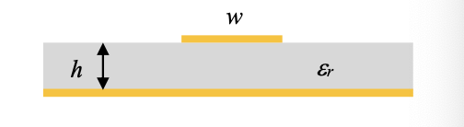
Note that the effective relative permittivity of the substrate depends on the width of the microstrip line. Therefore, it will be different for the main line, the stub lines, and the transformer lines! Also note that the length of the transformer line will in general be different in the different designs, since the characteristic impedance of the transformer lines will be different, and hence the widths will be different, giving different effective relative permittivities.

Figures Showing the Matching Schemes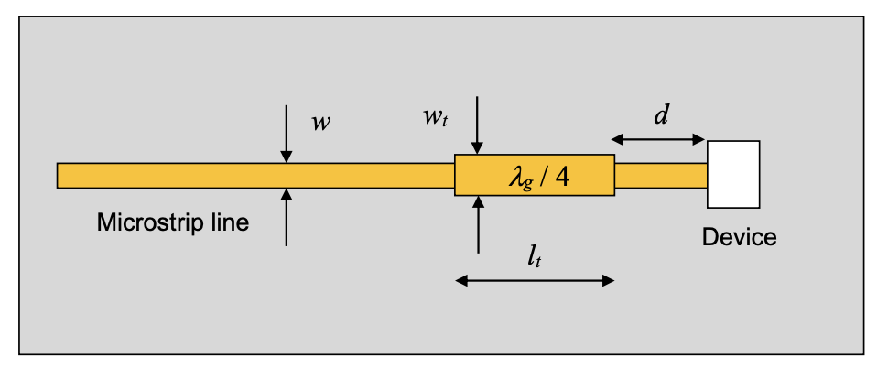
Figure 1. Geometry for design 1
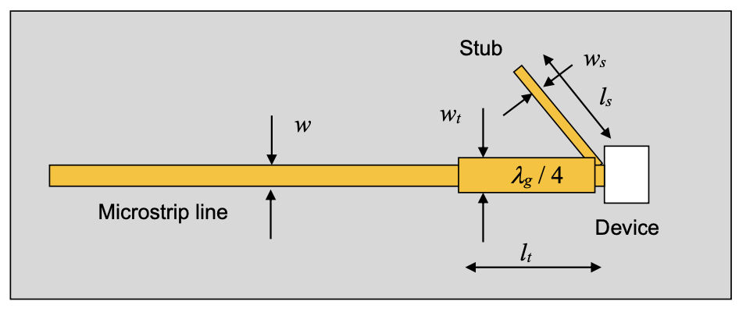
Figure 2. Geometry for design 2
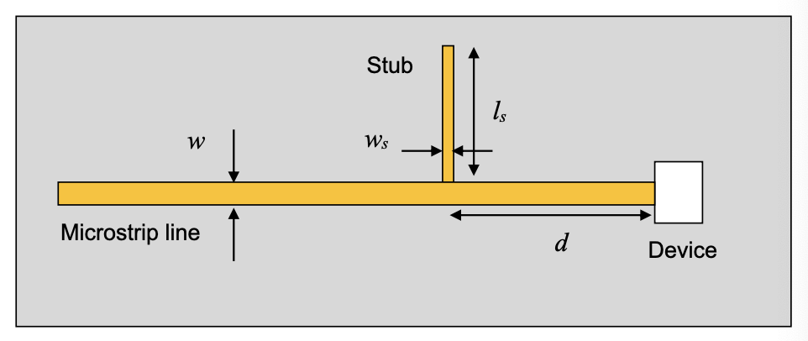
Figure 3. Geometry for design 3

Report Guidelines
Your report should consist of the following sections:
- Cover page
- Academic Honesty Statement
- Abstract
- Introduction
- Analysis and Design (give the three designs and the method of analysis)
- Results and Discussion (broken down by tasks)
- Conclusions
- References
- Appendix (optional)
Your report will be graded on the accuracy of your design and results, the quality of your plots, the quality of your discussion, and the grammar and writing style of your report. Do not make the report longer than it needs to be; you are not being graded on length.
Make sure that if you take any results, equations, figures, etc. from any source other than yourself (including the class notes or this handout), that you give proper credit.
The Academic Honesty statement should be a signed statement on a separate page that says "I have worked on this project entirely by myself, and I have not discussed this project with anyone other than the instructor."
If there are any corrections to the project, they will be posted on the class website.

References
[1] David M. Pozar, Microwave Engineering, 3rd edition, Wiley, 2005.

